TECHNICAL PROJECT REPORT

# Title of Invention / Project:

# Voice Controlled Extension Box/Chord

# Team Members / Inventors:

|  |  |  |  |  |  |
| --- | --- | --- | --- | --- | --- |
| **S.No.** | **Name** | **Department** | **Designation** | **Mobile** | **E-Mail** |
| 1. | Shaurya | AI & ML - 2 | Student | 9882558283 | sgulati1020@gmail.com |
| 2. | Rohan | AI & ML – 2 | Student | 9169167424 | rohanarora2000.ra @gmail.com |
| 3. | Rahul | AI & ML – 2 | Student | 8348536004 | i.rahuljana @gmail.com |
| 4. | Tushar Mahajan | AI & ML - 2 | Student | 7888556983 | tusharmahajan1609@gmail.com |
| 5. | Khushal Thakur | ECE | Mentor | 9646030764 | khushal.thakur@cumail.in |
| 6. | Anshul Sharma | ECE | Mentor | 9478697475 | anshulsharma.ece@cumail.in |
| 7. | Kiran Jot Singh | ECE | Mentor | 9463909689 | kiranjotsingh.ece@cumal.in |
| 8. | Divneet Singh Kapoor | ECE | Mentor | 9878422653 | divneet.ece@cumail.in |

SECTION-1(IPR Related)

BRIEF ABSTRACT:

A Voice Controlled Extension Box: We have made the exact same thing as the image gets to your mind after reading the name. The Voice Controlled Extension box or Chord takes the commands through a mobile app in order turn on or turn off the switches present on the extension board. This is an IOT based project and a small scale or a small model for home automation project i.e. Our starting with home automation.

**HOW ARE WE SOLVING THE PROBLEM :**

In todays world, who doesn’t want comfort and ease. Thus, because of that ease, we are constantly shifting to the technology. Our project is not actually a problem solver. It’s an enhancer in todays technology with the use of voice control and its pretty modern to give command by voice and get the task done.

**ADDITIONAL MODIFICATIONS THAT CAN CATER TO IMPROVED SOLUTION:**

Currently we are using the app for giving commands and its just used for the extension board but we will take it to the next level by home automation and will try not to have an app and use an inbuilt microphone for commands in the appliance but that will gradually increase the cost too.

# Existing state-of-the-art and Drawbacks in existing state-of-the-art

|  |  |  |
| --- | --- | --- |
| **S. No.** | **Existing state of art** | **Drawbacks in existing state of art** |
| 1 | A voice controlled extension box using commands given with the help of an app.  Patent no. US4597077A  Google patents links :  <https://patents.google.com/patent/US4597077A/>  en?q=voice&q=control&q=switch&q=board&  oq=voice+control+switch+board+ | Using an app for giving commands and limited number of switches available. |

Novel/Additional modifications that you can propose to improve upon drawbacks:

1. Using Additional Microphone.
2. Using some other appliances too.
3. Limited number of works done by the box.

# Advantages:

The advantage is It’s a modern technology and voice controlled. Everybody is moving towards modernisation and home automation.

**SECTION-2 (REAL PROJECT)**

**MATERIALS:**

|  |  |
| --- | --- |
| **MATERIALS** | **COST**  (in Rs.) |
| **Arduino Uno** | **380** |
| **Bluetooth Module (HC-05)** | **300** |
| **5V 2 Channel Relay** | **200** |
| **Switch Board** | **150** |
| **Switches and Plug** | **150** |
| **Jumper wires** | **50** |
| **10V Adapter** | **150** |
| **Cardboard Box** | **50** |
| **Toolkit** | **250** |

**CIRCUIT DIAGRAM:**

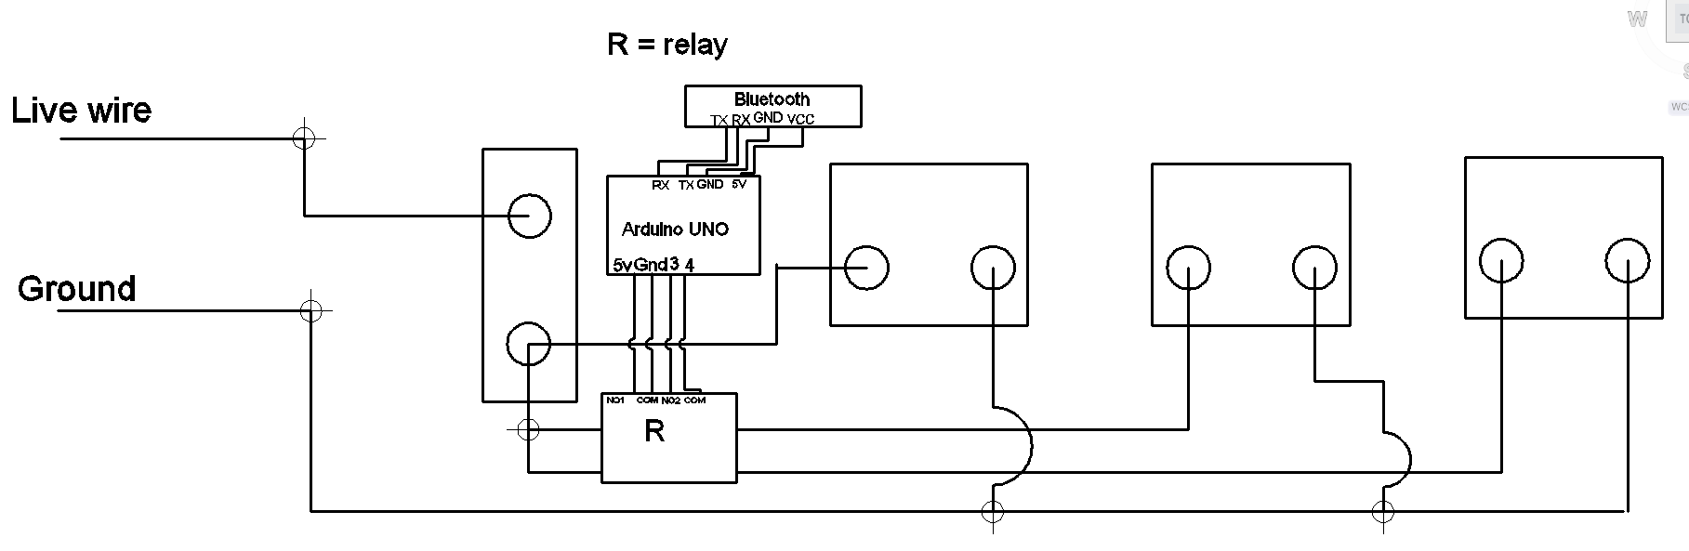

**STEPS OF CIRCUIT COMPLETION:**

It was not an easy task to complete our project as it consisted of complexities regarding the Code for Voice Recognition and The circuit. We had to go through alot of steps for our Project Completion:

1. Gathering all the material required for the circuit which included visiting electronics shop again and again as per the availability of different devices.

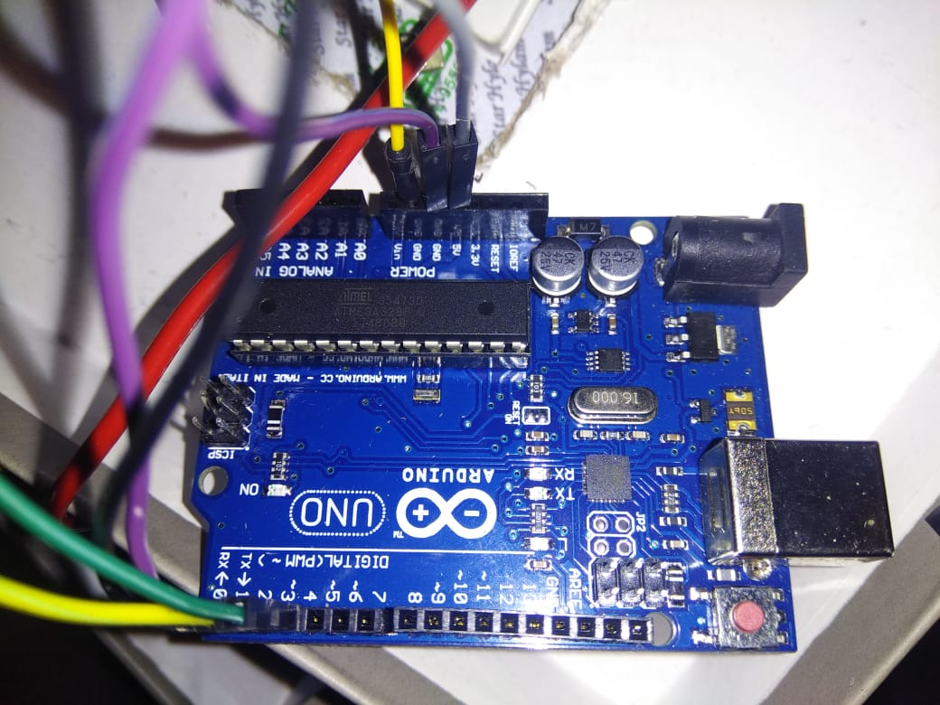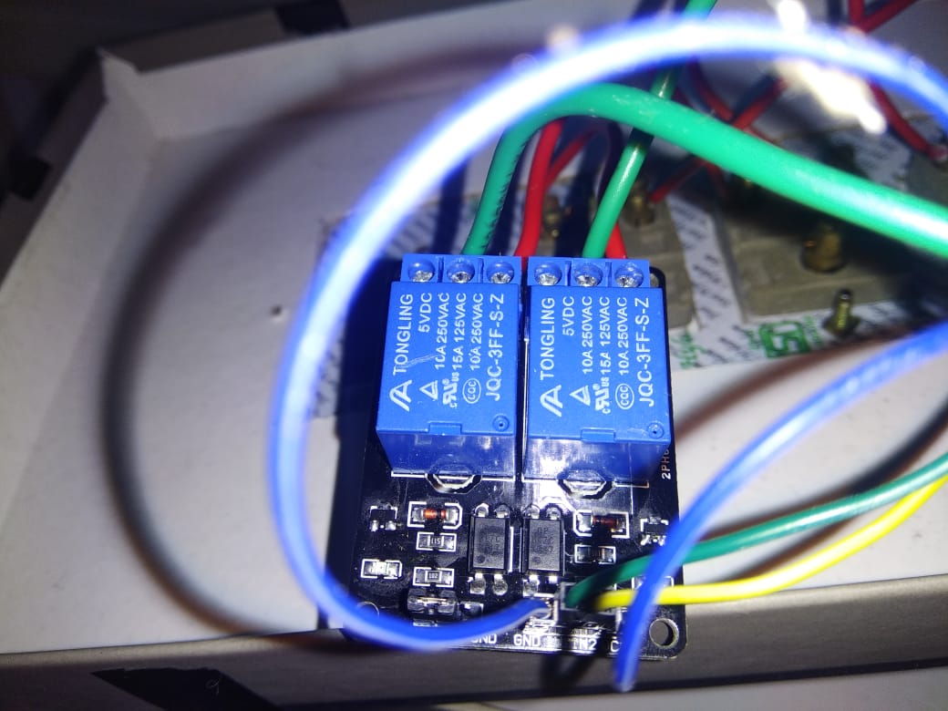

1. After learning about how to make connections, circuit formation started with connecting Arduino with different devices and the Bluetooth module and relay.
2. Successful and Working Connection of Arduino with the Relay.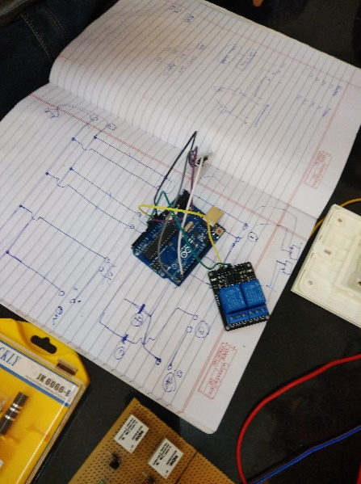
3. Further completion of circuit between Bluetooth Module, Relay and Arduino UNO.

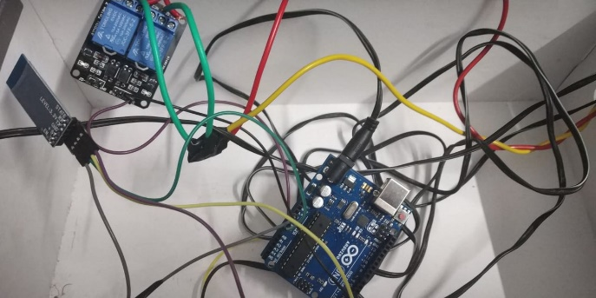

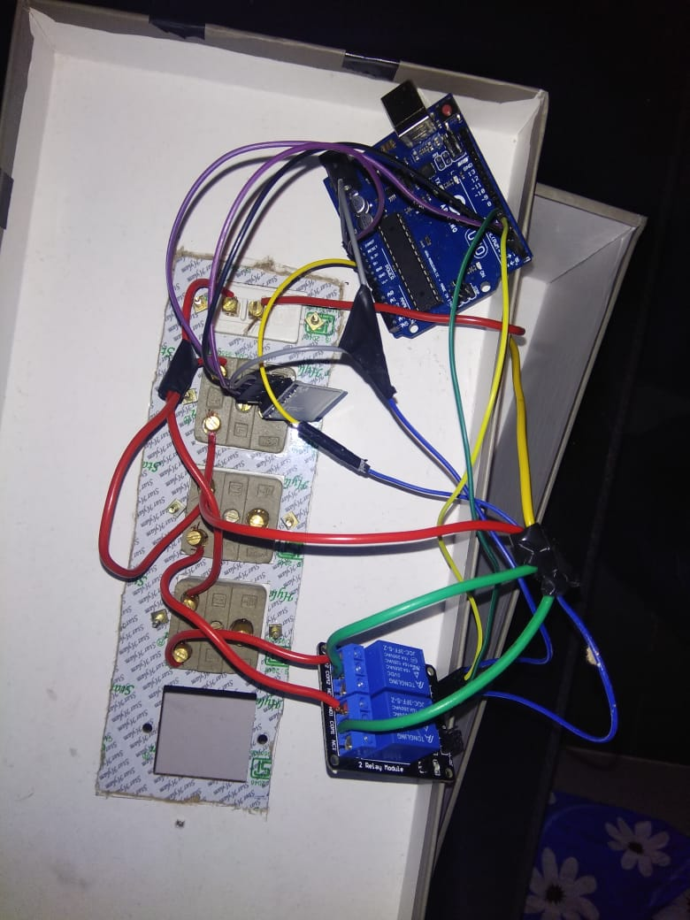

1. Finally having everything with us keeping in mind the placement of everything must look neat and clean.

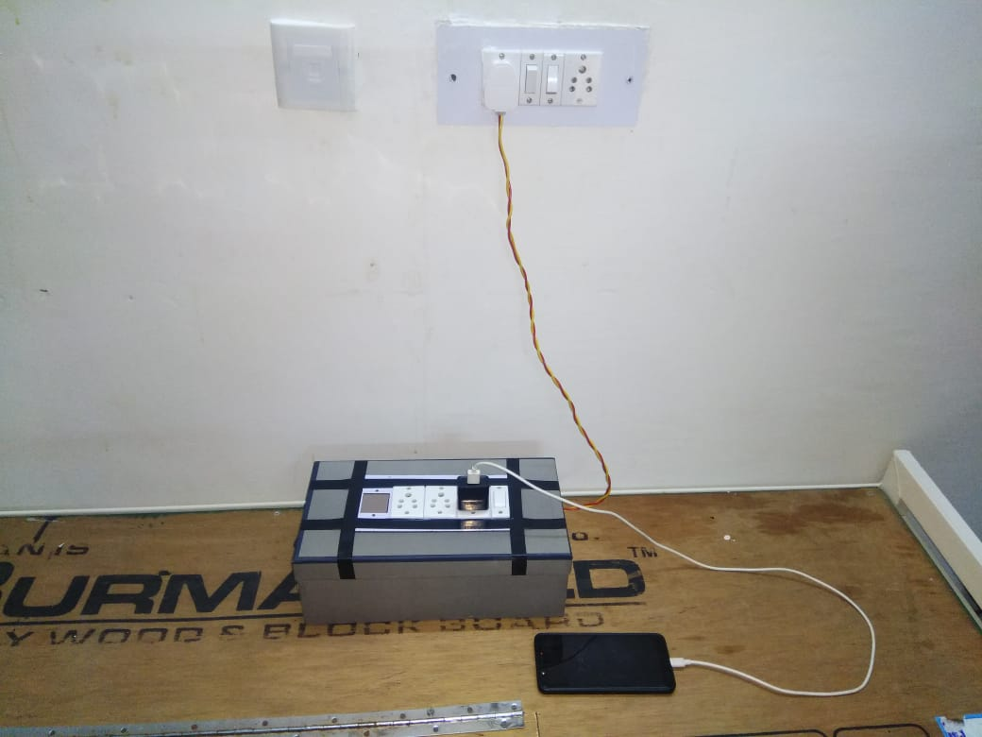

1. **CODING**

**PROGRAM CODE:**https://github.com/RahulJana/beee-project